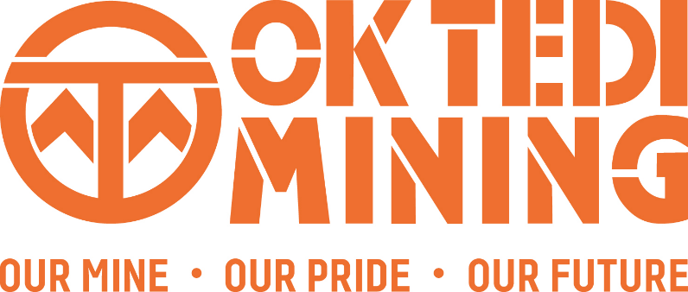

21/04/2022

**Fit For Work in Focus for Ok Tedi Mining Safety Week**

If you put the phrase, “Fit for Work” into the Google search engine, you get over 7,740,000,000 results. Clearly, it’s a hot topic! And it is the focus for Ok Tedi’s National Mining Safety Week (NMSW) 2022, to be celebrated from April 24 to 29.

Fit for work means that an individual is in a state (physical, mental and emotional) which allows them to perform daily duties/task effectively and in a manner that does not threaten their own or others safety or fitness for work.

At Ok Tedi, we believe “The wealth of business depends on the health and safety of workers”. We value strategic investment in human capital development. An important part of this investment is personalising safety to influence and upskill our employees to be fit for work.

So, while fitness for work at Ok Tedi starts with YOU, the responsibility for developing and presenting our NMSW program is shared right across the business at all levels of the organisation.

The key program during this weeklong event is:

* **Day 1 – Fun run**
* **Day 2 – Fit for work overview**
* **Day 3 – Fatigue, drugs and alcohol**
* **Day 4 – Advance Safety Awareness**
* **Day 5 – Mental health**
* **Day 6 – Occupational hygiene.**

We start the week by inviting everyone, at all levels of the organisation (and all levels of fitness), to participate in the fun run program as part of the opening event. Days 2 to 6 focus on a specific fitness for work topics and work teams are asked to participate by conducting discussions and participating in planned activities around each topic.

The newly established NMSW Steering Committee will provide support to all key stakeholders including POM, Kiunga, Bige and Tabubil area (including mine and mills).

The steering committee includes representation from GDS & apprentice groups as well as Contractors. It has been instrumental in developing activities that will run parallel to the main program and that will be accessible for all to participate in and enjoy, including a selfie video campaign, pedometer walking competition, STEM awareness and workplace design competition. See over for the full program.

We hope you will take part in Ok Tedi’s NMSW 2022 and that you and your work team can have some fun while also focussing on how our commitments to being fit for work before, during and after work can fully be realised.

Thank you,  
Anna Ila