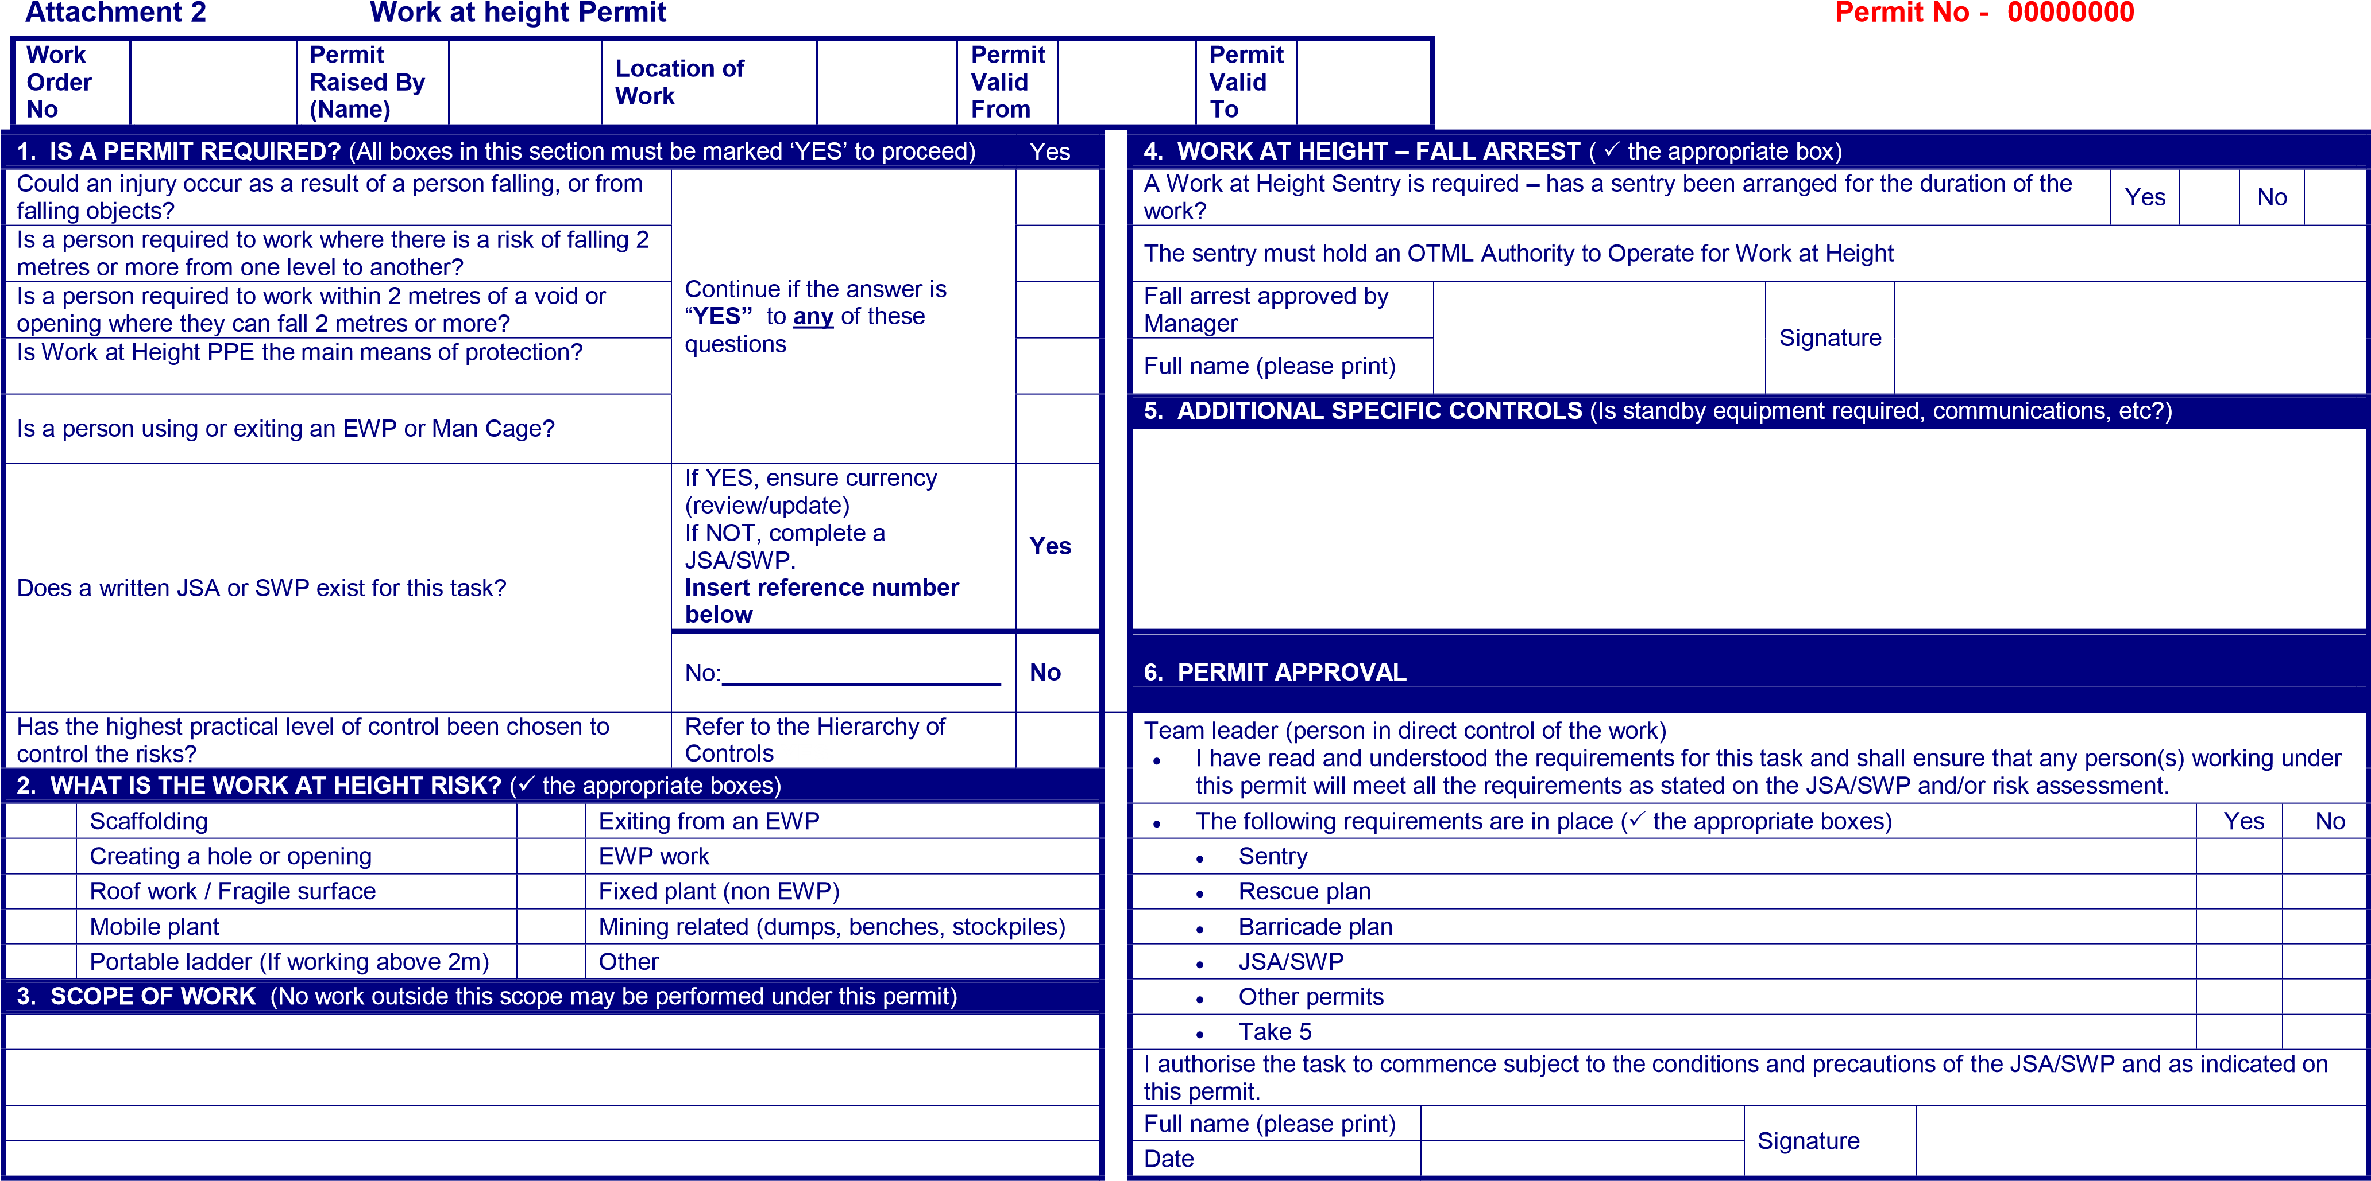

|  |  |  |  |  |  |
| --- | --- | --- | --- | --- | --- |
| Title | Sponsor | Issued | Last Review | Next Review | Page |

|  |  |  |  |  |  |  |  |  |  |  |  |  |  |  |  |  |
| --- | --- | --- | --- | --- | --- | --- | --- | --- | --- | --- | --- | --- | --- | --- | --- | --- |
| **7. WORK CREW SIGN ON** | | As a member of this work crew I have read, understood and will comply with my duties as listed on this permit and attachments (e.g. risk assessment, JSA/SWP, checklist etc) | | | | | | | | | | | | | | |
| **Name** | **Company** | | **Sign-on** | | **Time** | | **Sign-off** | **Time** | **Name** | | **Company** | | **Sign-on** | **Time** | **Sign-off** | **Time** |
| 1. |  | |  | |  | |  |  | 6. | |  | |  |  |  |  |
| 2. |  | |  | |  | |  |  | 7. | |  | |  |  |  |  |
| 3. |  | |  | |  | |  |  | 8. | |  | |  |  |  |  |
| 4. |  | |  | |  | |  |  | 9. | |  | |  |  |  |  |
| 5. |  | |  | |  | |  |  | 10. | |  | |  |  |  |  |
| **8 A. APPROVAL TO WORK IN A RESTRICTED CAPACITY -** | | | | | | | | | | | | **8 B. Approval by General Manager / Executive Manager** | | | | |
| **Work Crew Assessed as competent to wear harness and in using attachments as per the SWP for the task** | | | | **□ Yes** | | **Name:** | | | | **Signature:** | | **Name** | | **Signature:** | | |
| **9. RECORD KEEPING** | | | | | | | | | | | | | | | | |
| Original | | | To be kept with the JSA/SWP at the work site until the job has been completed and the permit closed. Once this is done the original permit may be disposed of. | | | | | | | | | | | | | |
| Copy | | | To remain in the permit book. | | | | | | | | | | | | | |

OHS Standard 5-31 Work at Height HSLT Chairman 12/11/2007 02/12/2009 02/12//2012 1 of 2

|  |  |  |  |  |  |
| --- | --- | --- | --- | --- | --- |
| Title | Sponsor | Issued | Last Review | Next Review | Page |

OHS Standard 5-31 Work at Height HSLT Chairman 12/11/2007 02/12/2009 02/12//2012 2 of 2